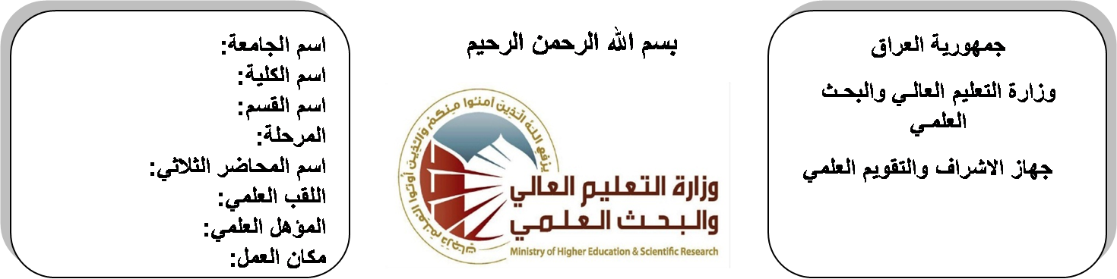

**اسم الجامعة:ديالى**

**اسم الكلية:الهندسة**

**اسم القسم: الالكترونيك**

**المرحلة: الرابعة**

**اسم المحاضر : د. محمد سلمان**

**اللقب العلمي: مدرس**

**المؤهل العلمي: دكتوراه**

**مكان العمل: كلية الهندسة**

**(( استمارة الخطة التدريسية))**

|  |  |  |  |
| --- | --- | --- | --- |
| **محمد سلمان صالح** | | | **اسم التدريسي:** |
| **mohselman@gmail.com** | | | **البريد الالكتروني:** |
| Artifacial Intellegent | | | **اسم المادة:** |
| **The aim of the AI is to get the** introduction to **neural networks & fuzzy logic**, its development and implementation. It includes; neural versus conventional computing. learning processes. the preceptor. The backpropagation learning algorithm. self-organization feature maps. applications. And introduction to fuzzy theory. fuzzy logic. fuzzy logic in engineering. fuzzy logic is a tool that can be applied to ambiguous, complicated, complex, or nonlinear systems or problems, which cannot easily solved by classical techniques. this course discusses the fundamental of fuzzy set theory and fuzzy logic. in addition, this course also introduces applications of fuzzy logic in several areas such as fuzzy control and fuzzy decision making. | | | **أهداف المادة:** |
|  | | | **الكتب المنهجية:** |
| [1] Jacek M. Zurada, *"****introduction to artificial neural systems****"*  [2] T. J. Ross, ***"fuzzy logic with engineering applications"*** | | | **المصادر الخارجية:** |
| **الامتحان النهائي** | **الفصل الثاني** | **الفصل الأول** | **تقديرات الفصل:** |
| 60% | 20% | 20% |
|  | | | **معلومات إضافية:** |

**جدول الدروس الأسبوعي – الفصل الدراسي الأول**

|  |  |  |  |  |
| --- | --- | --- | --- | --- |
| **الملاحظات** | **المادة العملية** | **المادة النظرية** | **التاريخ** | **الأسبوع** |
|  |  | Introduction of AI |  |  |
|  |  | Introduction of Neural Network |  |  |
|  |  | Types of Neural Network |  |  |
|  |  | Forward network |  |  |
|  |  | Forward network |  |  |
|  |  | Perceptron Nerun |  |  |
|  |  | Perceptron Nerun |  |  |
|  |  | Associative Memory |  |  |
|  |  | Hopfield Neural Network |  |  |
|  |  | Hopfield Neural Network |  |  |
|  |  | BAM Neural Network |  |  |
|  |  | BAM Neural Network |  |  |
|  |  | Hamming Neural Network |  |  |
|  |  | Hamming Neural Network |  |  |
|  |  | BackPrpagation learning |  |  |
|  |  | BackPrpagation learning |  |  |
|  |  | MultiLayer Neural Network |  |  |
|  |  | MultiLayer Neural Network |  |  |
|  |  | Introduction to Fuzzy Logic System FLS |  |  |
|  |  | Basic elements for FLS |  |  |
|  |  | Fuzzy Sets and its relationship |  |  |
|  |  | Universe of Discourse and fuzzy set |  |  |
|  |  | Rules for FLS |  |  |
|  |  | Defuzzyfaction methods |  |  |
|  |  | Design FLS |  |  |
|  |  | Design FLS |  |  |
|  |  | Design FLS |  |  |
|  |  | FLS applications |  |  |
|  |  | FLS applications |  |  |
|  |  | FLS applications |  |  |

**توقيع الأستاذ: توقيع رئيس القسم توقيع العميد:**

**د. محمد سلمان صالح د. محمد سلمان صالح**